How to create a root locus graph

1. Draw your poles and zeros on the graph.
2. Find alpha.

To find alpha, subtract the number of poles from the number of zeros.

1. Use alpha to find sigma.

Sigma = (sum of the pole locations - sum of zero locations) / alpha

Sigma represents the origin of your asymptotes.

1. Get each angle measure. This angle measure represents the angle each asymptote makes with the positive real axis.

180n/alpha = xn,

Where n = +-1,+-3, +-5….

1. Draw the asymptotes starting from Sigma, until infinity. These asymptotes are based on the angle measures we just found, relative to the positive real axis.
2. Root locus exists to the left of an odd number of poles or zeros on the positive real axis.
3. To check any point to see if it lies on the root locus, use the angle condition.

Angle condition:

180n = (sum of all zero angle locations - sum of all pole locations)

Then check to see if it's possible.

1. If there's a third pole (if the pole pulls the root locus to the left or right to make a circle), then you can set the characteristic equation equal to zero, them take the derivative with respect to K, set it equal to zero, and then find the roots to get the re-entry point and break away point. When you take the derivative, my recommendation is to distribute the factors, to make taking the derivative easier. Alternatively, if the root locus makes a circle, then you might already know the radius and be able to skip this step. (Double checking is always a good idea though)

.

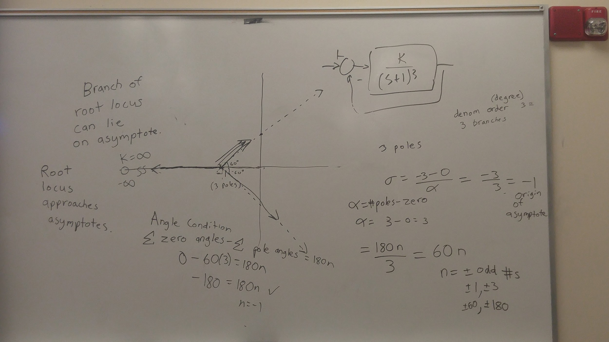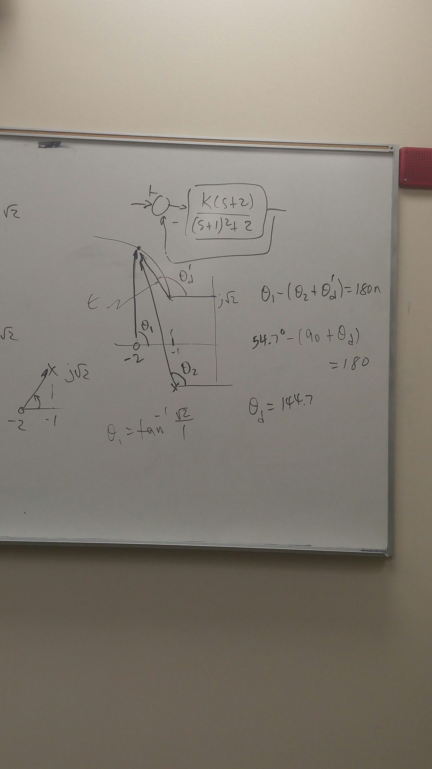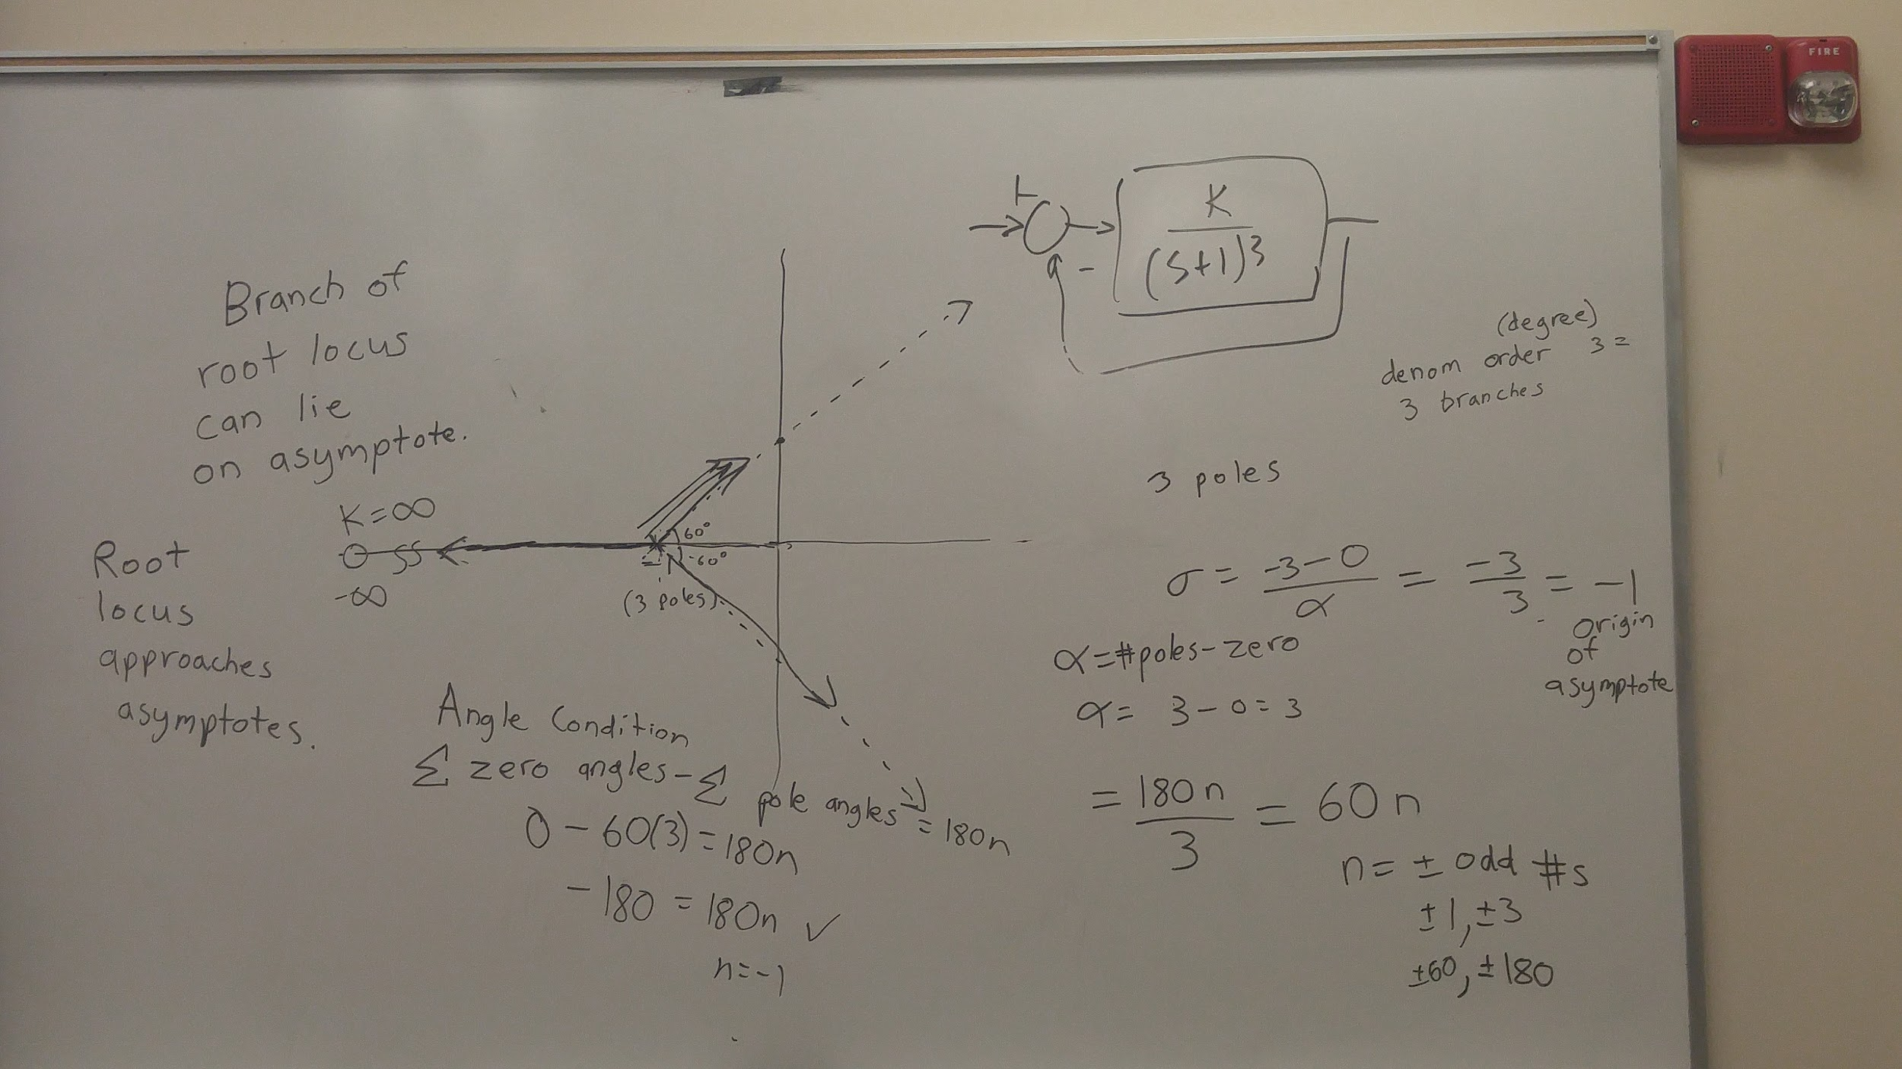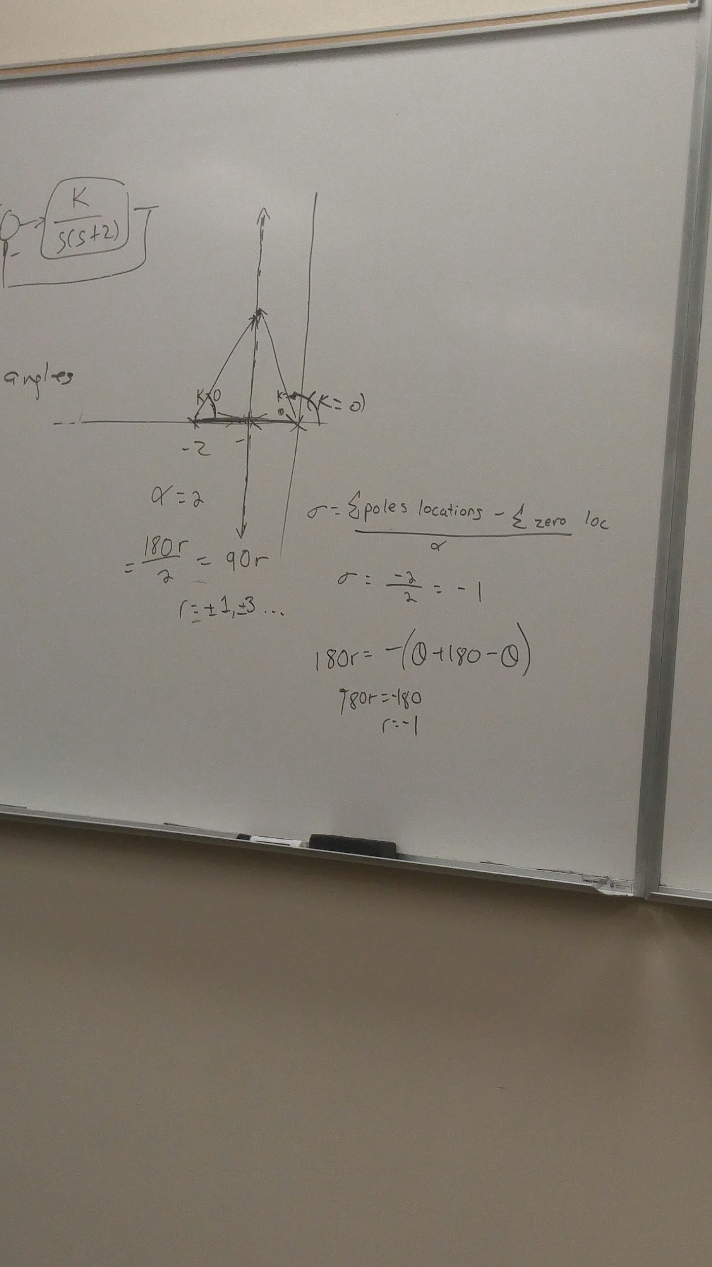

r

Underdamped means zeta < 1

Critically damped means zeta = 1

Overdamped, zeta > 1